**Programming Paradigms:**

**Coursework 1**

**Testing**

**2024-2025**

**Department of Computing**

**Submitted for the Degree of**:

BSc Software Development for Business

**Name:** Vincenzo Russo

**Programme :** Software Development for Business

**Matriculation Number:** S2336012

**“Except where explicitly stated, all work in this report, is my own original work and has not been submitted elsewhere in fulfilment of the requirement of this or any other award”**



**Signed by Student:___________________ Date:** 11/12/2024



Table of Contents

Table of Figures 2

Table of Tables 2

1. Test Log 3

Appendices 6

Appendix A: 6

Table of Figures

Figure 1 6

Figure 2 7

Figure 3 8

Figure 4 9

Figure 5 10

Figure 6 11

Figure 7 11

Figure 8 12

Figure 9 12

Figure 10 13

Figure 11 13

Figure 12 13

Figure 13 14

Figure 14 14

Figure 15 14

Figure 16 15

Figure 17 15

Figure 18 15

Table of Tables

Table 1: Test Cases 3

# Test Log

The following section contains the test cases for the Formula 1 console application written in Scala. Each test includes the respective test number, any input or actions needed, the expected output, actual output, result and screenshot reference number – included in the appendices. See next page and Appendix A.

|  |  |  |  |  |  |
| --- | --- | --- | --- | --- | --- |
| **Test No.** | **Input/Action** | **Expected Output** | **Actual Output** | **Result** | **Screenshot Reference** |
| **1** | Start application. | Console welcomes user, prompts user to input number 1-7. | As expected. | **Pass** | Figure 1 |
| **2** | Start application. Input ‘1’, hit enter. | Console prints “Option 1 selected…”. Console then prints all season winners with their points and wins for that year, then loops back to menu prompting another selection. | As expected. | **Pass** | Figure 2 |
| **3** | Start application. Input ‘2’, hit enter. Input ‘2017’, hit enter. | Console prints “Option 2 selected…”. Console prints “Please enter the season you want to display:”. Console prints all statistics of each driver for that season inputted, then loops back to menu prompting another selection. | As expected. | **Pass** | Figure 3 |
| **4.1** | Start application. Input ‘2’, hit enter. Input ‘s’, hit enter. | Console prints “ Invalid input 's'. Please enter a valid year between 2017 and 2023.”, then loops back to menu prompting another selection. | As expected. | **Pass** | Figure 4 |
| **4.2** | Start application. Input ‘2’, hit enter. Input ‘2016’ (invalid year), hit enter. | Console prints “Invalid input '2016'. Please enter a valid year between 2017 and 2023.”, then loops back to menu prompting another selection | As expected. | **Pass** | Figure 5 |
| **5** | Start application. Input ‘3’, hit enter. | Console prints “Option 3 selected…”. Console prints total wins per season, then loops back to menu prompting another selection. | As expected. | **Pass** | Figure 6 |
| **6** | Start application. Input ‘4’, hit enter. | Console prints “Option 4 selected…”. Console prints average points per season rounded up, then loops back to menu prompting another selection. | As expected. | **Pass** | Figure 7 |
| **7** | Start application. Input ‘5’, hit enter. | Console prints “Option 5 selected…”. Console prints total points per season ascending, then loops back to menu prompting another selection. | As expected. | **Pass** | Figure 8 |
| **8.1** | Start application. Input ‘6’, hit enter. Input ‘Lewis Hamilton’, hit enter. | Console prints “Option 6 selected…” Console prints “Please enter the player you want to display (case sensitive):”. Console prints driver and their total points, then loops back to menu prompting another selection. | As expected | **Pass** | Figure 9 |
| **8.2.** | Start application. Input ‘6’, hit enter. Input ‘2’, hit enter. | Console prints “Invalid input ‘2’. The name wasn’t found. Please enter a valid name from the list…”, then loops back to menu prompting another selection. | As expected. | **Pass** | Figure 10 |
| **8.2** | Start application. Input ‘6’, hit enter. Input name with wrong case last name, e.g., ‘Lewis hamilton’, hit enter. | Console prints driver and their total points, then loops back to menu prompting another selection. | As expected. | **Pass** | Figure 11 |
| **8.4** | Start application. Input ‘6’, hit enter. Hit enter. | Console prints “Invalid input ‘’. The name wasn’t found. Please enter a valid name from the list…”, then loops back to menu prompting another selection. | As expected. | **Pass** | Figure 12 |
| **8.5** | Start application. Input ‘6’, hit enter. Input name with three names, e.g., ‘Paul di Resta’. Hit enter. | Console prints driver and their total points, then loops back to menu prompting another selection. | As expected. | **Pass** | Figure 13 |
| **8.6** | Start application. Input ‘6’, hit enter. Input name with three names with wrong case in middle name, e.g., ‘Paul Di Resta’. Hit enter. | Console prints driver and their total points, then loops back to menu prompting another selection. | As expected. | **Pass** | Figure 14 |
| **8.7** | Start application. Input ‘6’, hit enter. Input name with inappropriate spaces, e.g., ‘Lewis Hamilton’. | Console prints driver and their total points, then loops back to menu prompting another selection. | As expected. | **Pass** | Figure 15 |
| **9.1** | Start application Input ‘7’, hit enter. | Console prints “Option 7 selected…” Console prints “Quitting the application…” Application quits. | As expected. | **Pass** | Figure 16 |
| **9.2** | Start application with no ‘data.txt’ file present in filepath ‘./src/resources/data.txt’. | Console prints “Error reading file: ./src/resources/data.txt (No such file or directory)”. Application quits. | As expected. | **Pass** | Figure 17 |
| **9.3** | Start application with empty data.txt file. | Console prints “Error: The data file is empty.” Application quits. | As expected. | **Pass** | Figure 18 |

# Appendices

## Appendix A:

**Figure 1**

**Figure 2**

**Figure 3**

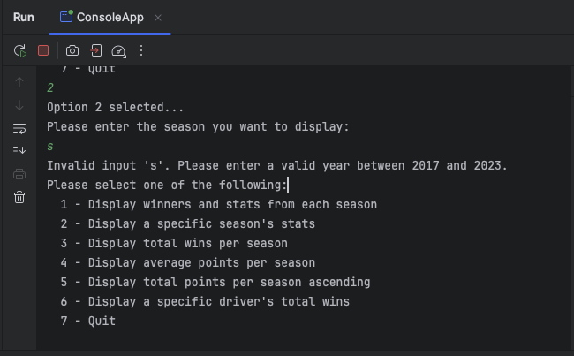

**Figure 4**

**Figure 5**

**Figure 6**

**Figure 7**

**Figure 8**

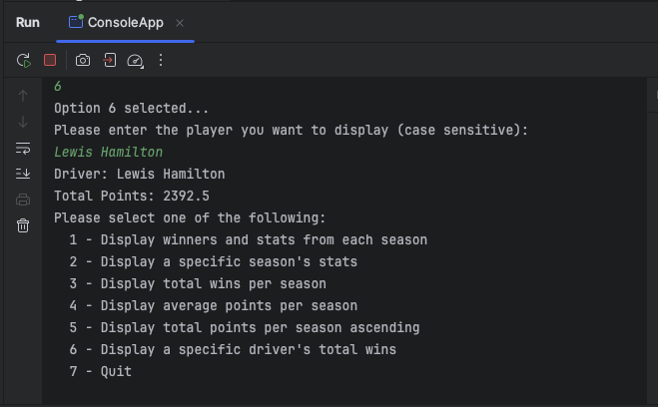

**Figure 9**

**Figure 10**

**Figure 11**

**Figure 12**

**Figure 13**

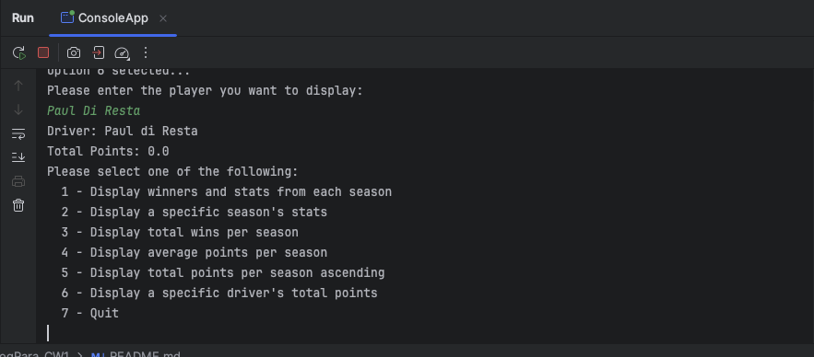

**Figure 14**

**Figure 15**

**Figure 16**

**Figure 17**

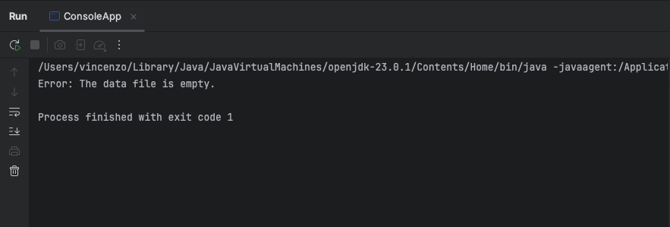

**Figure 18**